

**November Good News 2024**

**Our ministry vision for the Virginia Annual Conference is *“to be disciples of Jesus Christ who are lifelong learners, who influence others to serve.”***

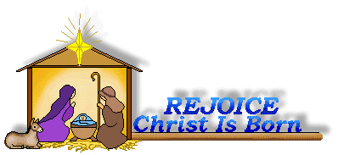

**From Pastor Adam**

*“Gratitude is Changing Lenses”*

*“Acknowledging the good that you already have in your life is the foundation for all*

*abundance.”* ~ Eckhart Tolle

*"We often take for granted the very things that most deserve our gratitude."* ~ Cynthia Ozick

*“Gratitude looks to the Past and love to the Present; fear, avarice, lust, and ambition look*

*ahead.”* ~ C.S. Lewis

If anything can be said of human beings, it is that we are consistently forward-looking: we plan, we prepare, we anticipate. We are quite often spending our days preparing for what tomorrow might bring. Of course, this is a necessity, and a noble one at that. However, there also lies the risk that we postpone the full enjoyment of the present for some future we are ever building. Sometimes we can postpone joy for some future date, saying to ourselves things like: “When I graduate from college, then my life will truly begin; when I get my first job, then my life will truly begin, when I get married and have a family, my life will truly begin; when I get this mortgage paid off, my life will truly begin; when I write the last college tuition check, then my life will truly begin; when I retire, my life will truly begin; when I have enough of everything, then my life will truly begin.”

There is something important about paying attention to the gifts of God we have received in days gone by, and the gifts of God we enjoy presently, that inspires gratitude in a way that we cannot experience when we are banking our whole existence on the future. In short, gratitude is a matter of changing lenses, so that our focus can be redirected to the discovery and celebration of the good things we already have in the active present and the recent past. Gratitude is the most liberating and life-giving sentiment. As we look to Thanksgiving Day, that great national day of gratitude, may we have our *“lenses”* focused on the treasures hiding right under our noses and every blessing along the way. And may we have the courage to let the “future be the future” as we leave those things to mercy and providence of God. God bless you, my friends! Happy Thanksgiving!

  God bless you my friends, Adam

 Circle News

The Wesleyan Group will meet on Monday, November 11th at 7:00 p.m., at the

home of Jane White. *~Ann Robbins*

The Merry Marthas Circle will meet on Thursday, **November 21**, 2024, at 10:30 a.m., at church. We will take up the World Thank Offering and have a short devotional and business meeting. We'll have lunch at Charley's at 12:00 noon. We will **not** meet in December, but will resume 4th Thursday meetings on January 23rd.

  ~*Judy Robertson*



**The choir** will be singing on Sunday, November 10, 2024. We will be rehearsing at 10:00 a.m. We will sing familiar hymns so please come join us!

*~Heather Wilson*, Director of Music

**Food Cart: November**

***Side dishes*** *for a holiday meal such as:* stuffing mix, cranberry sauce, biscuit mix, as sorted canned vegetables, etc.

*No* ***“baked goods”****!* *Place donations in the grocery cart, located in the Commons*.

Coming Up…

***Annual Charge Conference***

*Peaks View Region ~* Sunday, November 17th *@* 3:00 p.m.~Fort Hill UMC

(106 Oakridge Blvd, Lynchburg)



**Daylight Saving Time ends** on Sunday, November 3rd. Remember to FALL back one (1) hour on Saturday evening, November 2nd.

Pizza Lunch

We will have a pizza lunch after church on **Sunday, November 10**. This will be paid for out of our fellowship fund. Please come and enjoy! Invite friends or family. A RSVP form is provided in the bulletins so we can have a head count.

***From the Church Office***

Be sure and check out our website: www.chestnuthillumc.net. We post the Sunday bulletin each week and the newsletter. And visit our Facebook page under Chestnut Hill United Methodist Church. A video of our Sunday service is provided. **AND** if you have not submitted your email address to the church office, please do so.



**Coming Up**: We will be decorating our church for Christmas on **Tuesday, December 3rd**, at 9:30 a.m. Contact Judy Robertson if you can help!

*Chestnut Hill UMC extends Christian love and sympathy* to the family of *Darlene Winslow* and especially to her brother-in-law, Frank Stewart. Mrs. Winslow passed away on October 2, 2024.

***“Angel Tree”***

We will have an Angel Tree again this year for the children of Humankind "Ways to

Work" clients. The tree will be set up in the Commons on November 3rd, and hopefully will have 20 angels on it by November 10. As before, you may shop for any items on the angel tag **and return them to church by December 8**. Or you may opt to donate any amount toward the purchase of gifts by the Humankind staff. Checks are to be made out to ***“Chestnut Hill UMC”***, Memo: **Angel Tree**, and also are due by December 8th.

**Please take an angel ONLY**

**if you are going to shop**.

Be sure to sign the sheet on the podium beside the tree if you are taking an angel tag.  Thank you in advance for your generosity in making Christmas brighter for these children!

**Mitten Tree Trunk**

We will be collecting mittens, gloves, caps, scarves, and socks again this year for the "*Mitten Tree Trunk".* These will go to Humankind also. They also are greatly in need of warm jackets, all sizes. They can be new, gently used, and clean. They can even be adult sizes. These will be collected throughout the month of December, so you can wait and shop sales after Christmas if you like.

~*Pat Short*

**From Staff-Parish Relations Committee**

If you have any concerns or needs regarding Chestnut Hill you can always contact our Pastor, Adam White or our Associate, Erin Long. But you can also contact Maggie Musgrove, Chairperson, or any other SPRC member: Judy Robertson, Betty Taylor, Chet & Mary Walker. We like to keep in touch with our congregation.

**Sunday Schedule:**

Sunday School……………………………9:30 a.m.

Worship…………………………………10:30 a.m.

**Choir Schedule**:

Check bulletins for date/time

**Circles:**

Wesleyan Group ~ 2nd Monday ~ 7:00 p.m.

Merry Martha’s ~ 4th Thursday ~ 10:30 a.m.





2024

|  |  |  |  |  |  |  |
| --- | --- | --- | --- | --- | --- | --- |
| ***Sunday*** | ***Monday*** | ***Tuesday*** | ***Wednesday*** | ***Thursday*** | ***Friday*** | ***Saturday*** |
|  | | | | | **1**  10:00am Homeschool | **2** |
| **3** *All Saints Sunday*  *24th Sunday after Pentecost*  9:30am Sunday School  10:30am Worship | **4** | **5**  6:00 pm Finance  7:00 pm Church Charge Conference | **6** | **7** | **8**  10:00am Homeschool | **9** |
| **10** *25th Sunday after Pentecost*  9:30am Sunday School  10:00am Choir  10:30am Worship  11:45am Pizza Lunch | **11**  7:00pm Wesleyan Group @ Jane White’s home | **12**  7:00pm Homeschool Game Night | **13** | **14** | **15**  10:00am Homeschool | **16** |
| **17** *26th Sunday after Pentecost*  9:30am Sunday School  10:30am Worship  3:00pm Charge Conference @ Fort Hill UMC | **18** | **19** | **20** | **21**  10:30am Merry Martha's Circle | **22**  10:00am Homeschool  4:00pm HS Preteen Game Night | **23** |
| **24** *Christ the King Sunday*  9:30am Sunday School  10:30am Worship | **25** | **26** | **27** | **28**  *Church Office Closed* | **29**  *Church Office Closed* | **30** |

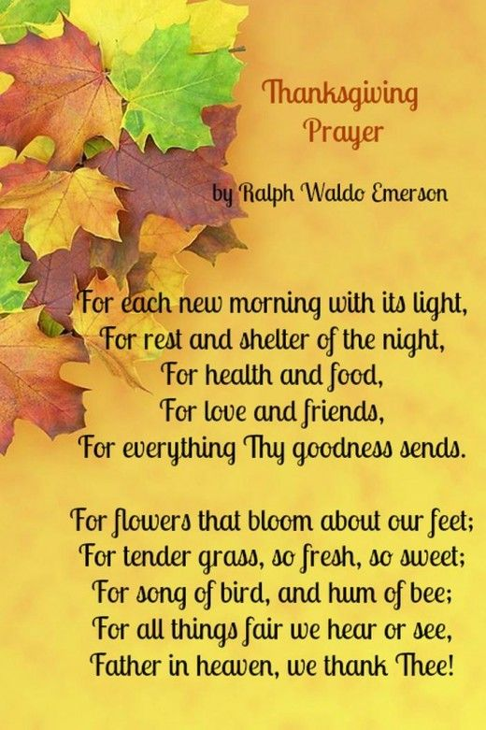

**Those Who Serve ~ October**

**GREETERS:**

November 3 ~ *Jane White*

November 10 ~ *Mary Walker*

November 17 ~ *Judy Robertson*

November 24 ~ *Maggie Musgrove*

**Our Church Financial Picture**

Through the end of September 2024

General Operating Funds:

Needed to meet our 2024 Budget $ 197,677

Needed to meet our budget to date $ 148,258

Actual receipts to date $ 110,704

Shortage to meet budget to date $ 34,554

Actual expenditures to date $ 124,751

Shortage to meet expenses to date $ 14,047

Joy In Missions Funds

Our Giving Goal for 2024 $ 8,600

Needed to meet our goal to date $ 6,450

Actual receipts to date $ 7,105

Special Offerings* (not budgeted):

Received to date $ 5,430

Dispersed to date $ 5,220

*Christmas, Easter, Annual Conference,

World Communion, etc.

**2024 Joy In Mission Donations**

To date, the following amounts have

been paid to the missions indicated.

Budget Spent

1. Missionary Covenant Relationship

$1,000 $ 1,000

2. Park View Mission, Food for Families

$3,000 $ 3,585

3. Society of St. Andrew $1,000 $ 1,000

4. Blue Ridge Area Food Bank $1,000 $ 1,000

5. Daily Bread $ 500 $ 375

6. Good Neighbor $ 500 $ 0

7. Habitat for Humanity $ 500 $ 375

8.. UMCOR-Non-Administrative $ 500 $ 0

9. Undesignated $ 600 $ 300

10. Meals on Wheels (Souper Bowl) $ 755

Thank you for your generosity.



1 Pat Short

2 Nancy Lee

Emily V.

Fernandez

3 Michael McGlothlin

6 Kirsten Bell

Tim Crist

Dennis Tolley

7 Kenny Busic

Cheryl Powell

9 Owen Stinnette

Jeremey

VandeBogart

11 Landen Glass

12 Camden Mason

14 Wade Ware

16 Burton Brooks

Terry Palazzi

Anne-Elaine Tiller

17 Suzanne

Marshall

Blake Phillips

18 Sharon

Rickmon

19 Connie Yost

20 Erin Ecklund

21 Steven Kinzer

22 C.O. Bell

25 Frankie

Hardwick

28 Jacqueline Busic

Cheryl Thomas

29 Wes Robbins

Ricky Smith

31 Robert Baunach

**2022**

**March 2022**

**GOOD NEWS** is

published monthly for members and

friends of Chestnut Hill United

Methodist Church. Send articles to

the church office by the 15th of the

month. (Subject to change).

**November Birthdays**

1 Jessica Robbins

5  Christopher Palazzi

8 Karsen Burgess

9 Sylvia Glass

10  Elizabeth Ashworth

11 Casey Fish

13 Pat Moore

14 Kathleen Baker

16  John Martin, Jr, Maggie Musgrove

17 Frank Stewart

24 Ann Ruhland

25  D’Lynn Burgess, Elizabeth Candler

26  Ella Dunn

27  Tad LeFew, III

30 Phillip Yost





January 2022

**2022**



**April 2022**

**April 2022**

**March 2022**

*Chestnut Hill United*

*Methodist Church*

4660 Fort Avenue, Lynchburg, VA 24502

Phone Number: 434-239-8423: FAX: 434-239-7209

E-mail: [chestnuthillumc@comcast.net](mailto:chestnuthillumc@comcast.net)

On the web: www.chestnuthillumc.net

Church Office Hours

**Monday-Thursday~**9:00 am—3:30 pm

**Friday~**9:00 am-1:00 pm

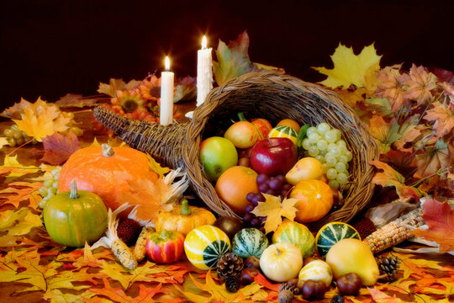

***DIRECTORY OF***

***CHESTNUT HILL UNITED METHODIST CHURCH***

|  |  |  |
| --- | --- | --- |
|  | Sue Haupert-Johnson | Richmond Area Resident Bishop |
|  | Rev. Dr. Sarah Calvert | Mountain View District Superintendent |
|  | Adam White | Minister |
|  | Erin Long | Associate Minister |
|  | Monica Campbell | Administrative Assistant |
|  | Heather Wilson | Director of Music Ministry |
|  | Judy Martin | Bookkeeper |
|  | Judy Robertson | Lay Leader |
|  | Elizabeth Nichols | Missionary in Henry County |